# [**'Criminal Minds' Star Set for 'Law & Order: SVU' in Rollins-Focused Episode Ahead of Exit**](https://popculture.com/tv-shows/news/law-and-order-svu-criminal-mines-lola-glaudini-guest-star-rollins-episode/)

**By** [**DANIEL S. LEVINE**](https://popculture.com/author/DanLevine/)- October 30, 2022 05:22 pm EDT

A former [*Criminal Minds*](https://popculture.com/streaming/news/criminal-minds-reboot-paramount-plus-gives-development-update/)star has booked a guest role in an upcoming *Law & Order: Special Victims Unit* episode. [Lola Glaudini](https://popculture.com/category/lola-glaudini/) will star in the Thursday, Nov. 3 episode, reports [*Give Me My Remote*](https://www.givememyremote.com/remote/2022/10/27/law-and-order-special-victims-unit-lola-glaudini-guest-star/). The episode will feature Det. [Amanda Rollins](https://popculture.com/category/amanda-rollins/), a month before [Kelli Giddish](https://popculture.com/category/kelli-giddish/)'s final episode airs.

The details of Glaudini's character are unknown. NBC's simple episode description notes that Rollins will be investigating the "assault by a masked man at an underground party." Meanwhile, Capt. Olivia Benson (Mariska Hargitay) finds a suspect in the case who might be "valuable as a witness."

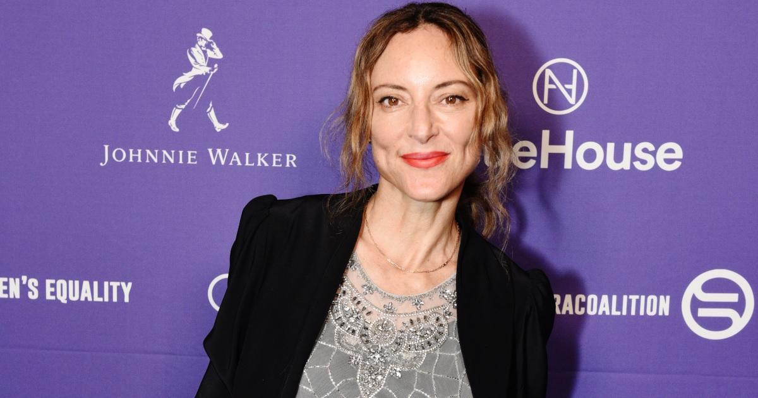(Photo: Vivien Killilea/Getty Images for Fund for Women's Equality)

Glaudini was one of the original stars of [*Criminal Minds*](https://popculture.com/tv-shows/news/criminal-minds-every-cast-member-who-is-confirmed-to-return/), playing FBI Supervisory Special Agent Elle Greenway. She appeared in the entire first season but left after only six episodes of Season 2. She was replaced by Paget Brewster's Emily Prentiss character.

Glaudini's big break came in 1997 when she had a recurring role on *NYPD Blue*. She appeared in the show's fifth and sixth seasons. Glaudini's other credits include *The Sopranos, The King of Queens, ER, Blue Bloods, White Collar, The Expanse, Marvel's Agents of SHIELD, The Brave,* and *Ray Donovan*. She recently played literary agent Candida Donadio in Paramount+'s limited series The Offer. Glaudini previously appeared in a 2012 *SVU* episode, "[Official Story](https://lawandorder.fandom.com/wiki/Official_Story)," playing the attorney of a security firm CEO who is sexually assaulted.

Giddish will [make her last appearance on SVU in the Thursday, Dec. 8 episode](https://popculture.com/tv-shows/news/law-order-svu-kelli-giddish-leaving-exit-date-revealed/). She joined the show at the start of Season 13 as one of the new detectives who replaced Det. Elliot Stabler (Christopher Meloni). Since then, Rollins has become an integral part of the show and [a close confidant for Benson](https://popculture.com/tv-shows/news/law-order-svu-mariska-hargitay-shares-sweet-moment-kelli-giddish/). Rollins is also in a relationship with A.D.A. Dominick "Sonny" Carisi (Peter Scanavino). Rollins [was shot in the abdomen](https://popculture.com/tv-shows/news/law-order-crossover-set-up-kelli-giddishs-svu-exit-rollins-shot/) during the premiere crossover with *Law & Order* and *Law & Order: Organized Crime*.

[0COMMENTS](https://popculture.com/tv-shows/news/cbs-reality-competition-moves-paramount-plus/#)

"Playing Rollins has been one of the greatest joys and privileges of my life. I've been so fortunate to be a part of the *Law & Order* family for the last 12 years," [Giddish wrote on Instagram](https://www.instagram.com/p/ChpwC2uJGA-/) in August. "There is simply no other character on TV like Rollins. She's grown and changed, and I have as well. I started on this show when I was in my late 20s and I'm grateful I got to spend so many of my adult years with Rollins in my life." *SVU* airs Thursdays at 9 p.m. ET on NBC, between *Law & Order* and *OC*. The show is also available to stream on Peacock.